Preview

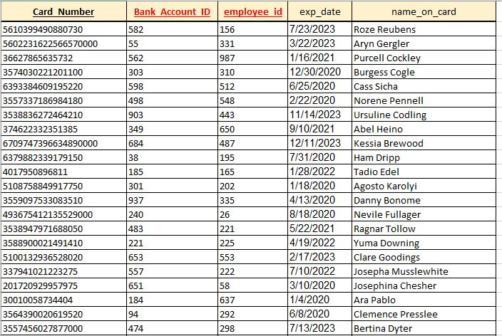

Table is in 3NF

PK is card_number.

FK’s are bank_account_ID and employee_ID